**Assignment 2**

**Kaushal kapadiya**

**Cs20m029**

**Group 10**

**Xquery**

1. Find the students having student with id > s003

<GET>  
{  
**for** **$s** **in** //**STUDENT**  
**where** **$s**[***@SID*** > "S003"]  
**return** **$s**  
}  
</GET>

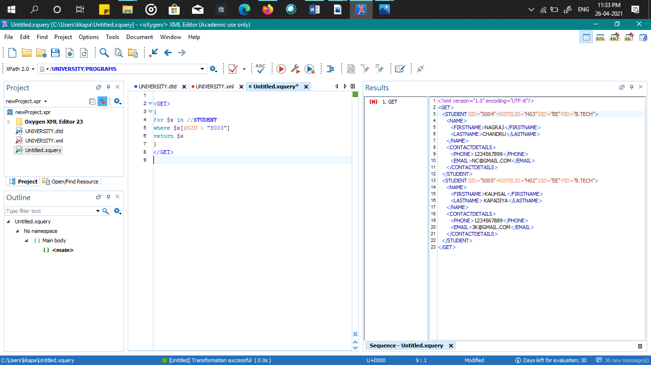

1. Find the total no of stdents ‘

<TOTALSTUDENT>  
{  
*count*(//**STUDENT**)

}  
</TOTALSTUDENT>

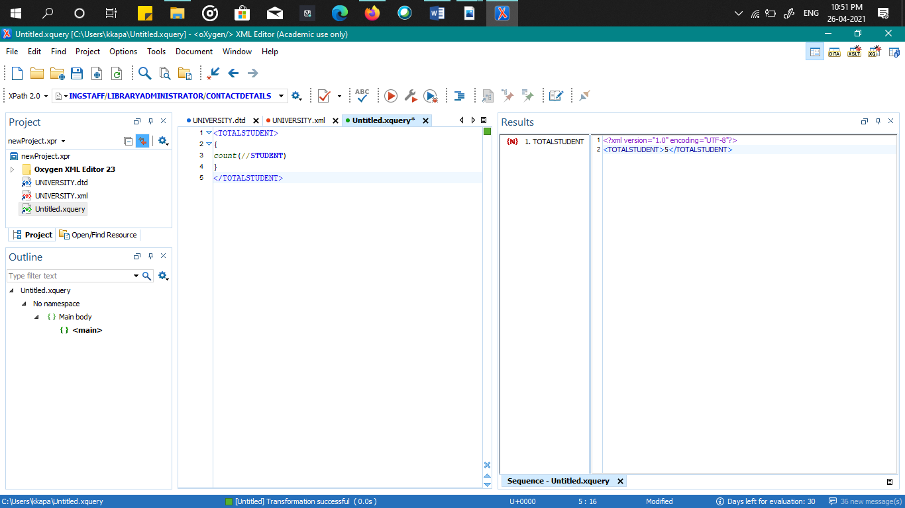

1. Find the total no of staff ‘

<TOTALSTAFF>  
{  
*count*(//**FACULTY**) + *count*(//**NONTEACHINGSTAFF**/*)  
}  
</TOTALSTAFF>

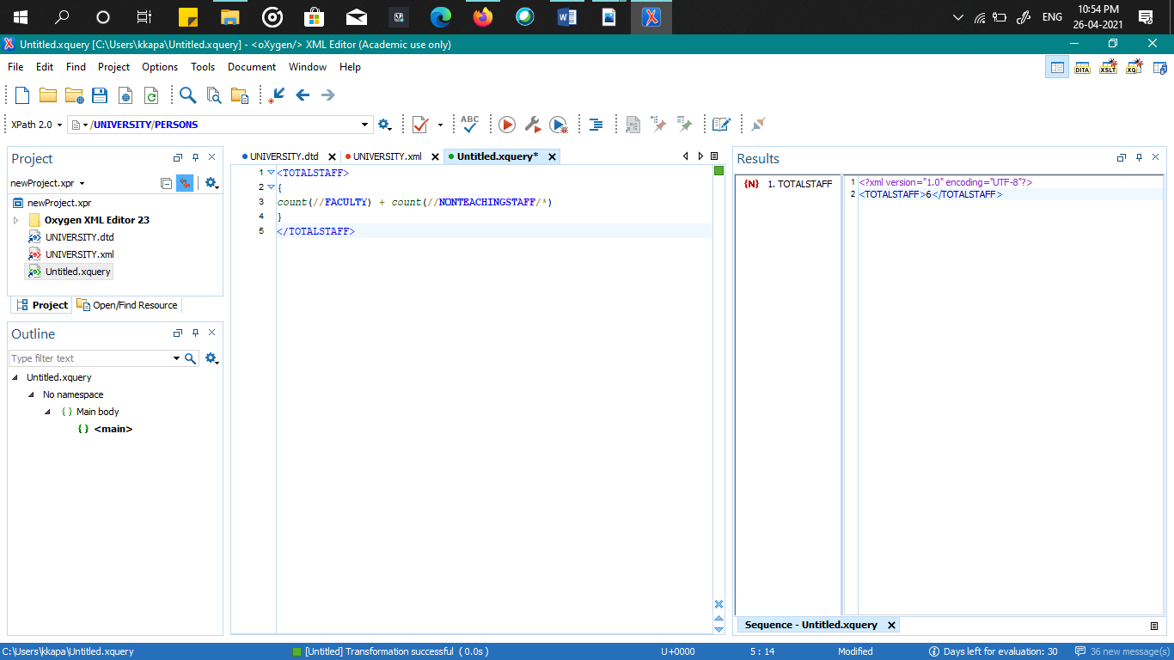

1. Find the total no of books

<TOTALBOOKS>  
{  
*count*(//**BOOK**)  
}  
</TOTALBOOKS>

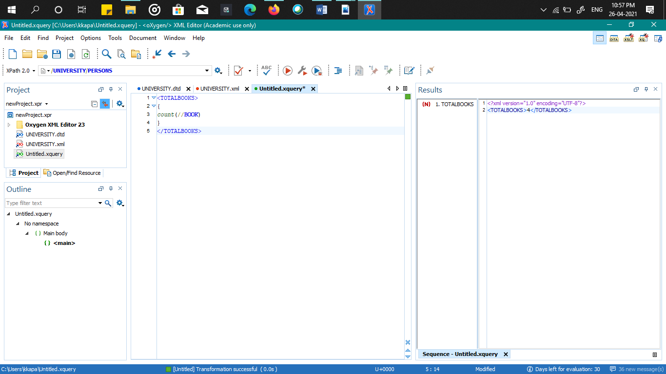

1. Get list of student name in ascending order

<GET>

{

for $s in //STUDENT

order by $s/NAME

return $s/NAME

}

</GET>

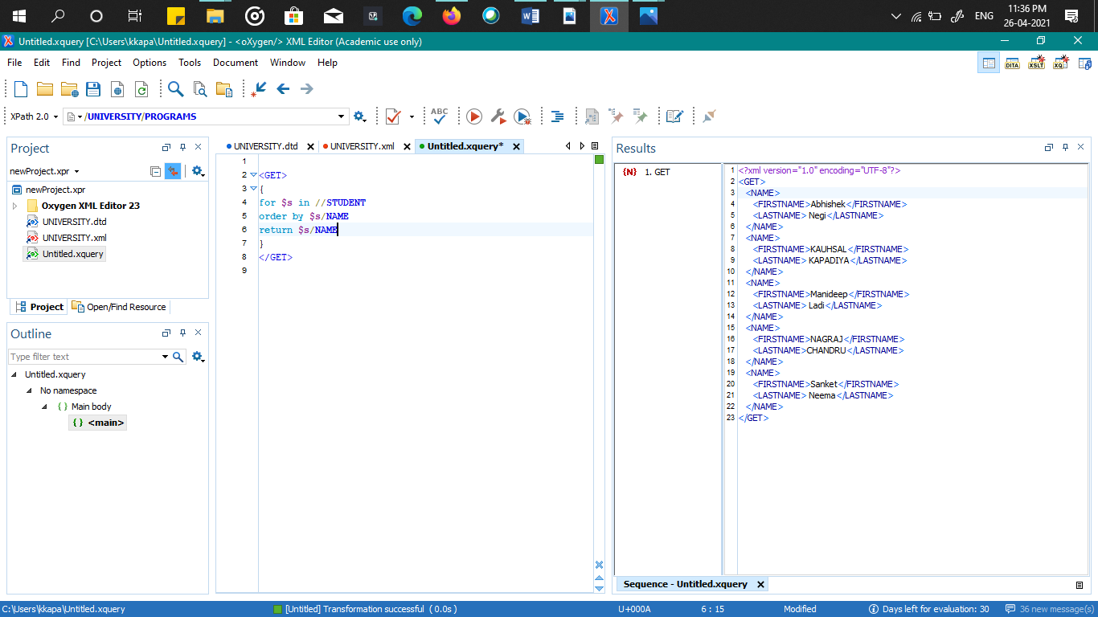

1. Find the author for the book id ISBN_0534950973

<GETAUTHOR>  
{  
//**BOOK**[***@BID*** = "ISBN_0534950973"]/**AUTHOR**  
}  
</GETAUTHOR>

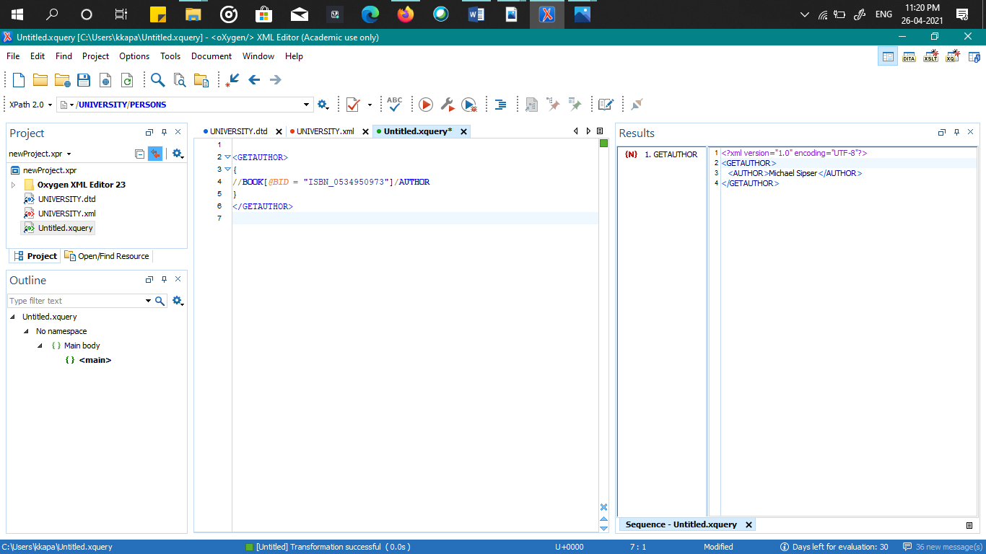

1. get all the attributes of hospital

<GETATTRIBUTE>  
{  
**for** **$h** **in** //**HOSPITAL**  
**let** **$t** := **$h**/*  
**return** **$t**  
}  
</GETATTRIBUTE>

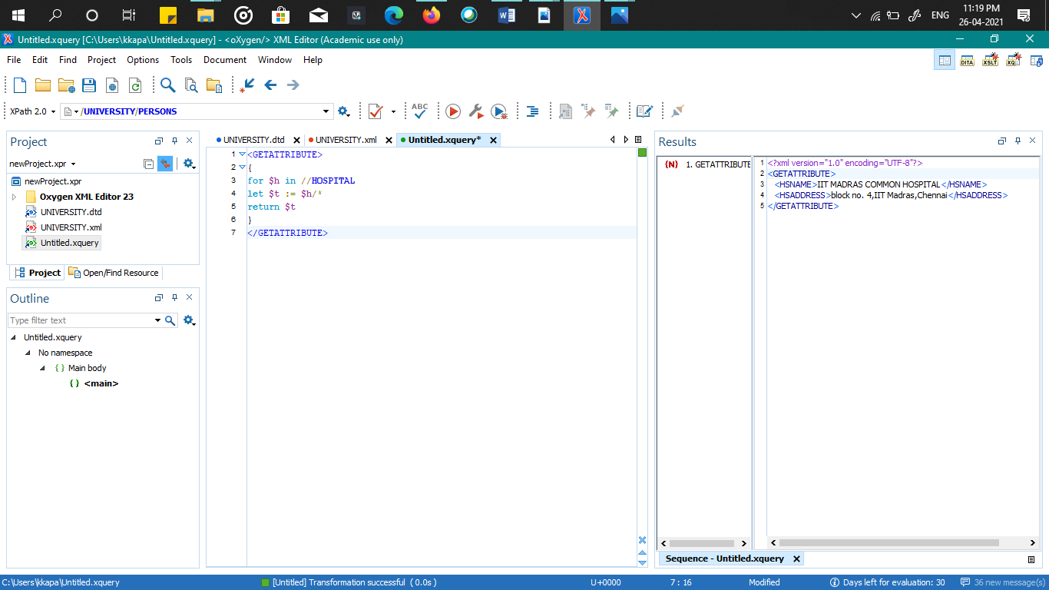

**xpath**

1. print the email id of the cse students ‘

//STUDENT/CONTACTDETAILS/EMAIL

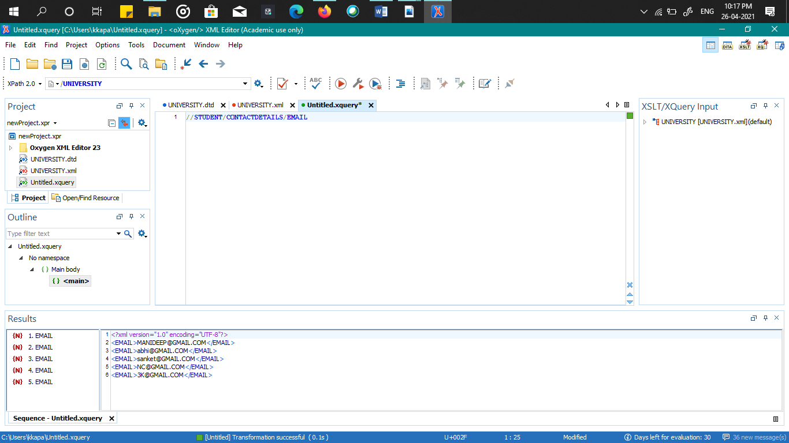

1. print the name of students who are in CSE department ‘

//STUDENT[@DID=”CSE”]/NAME

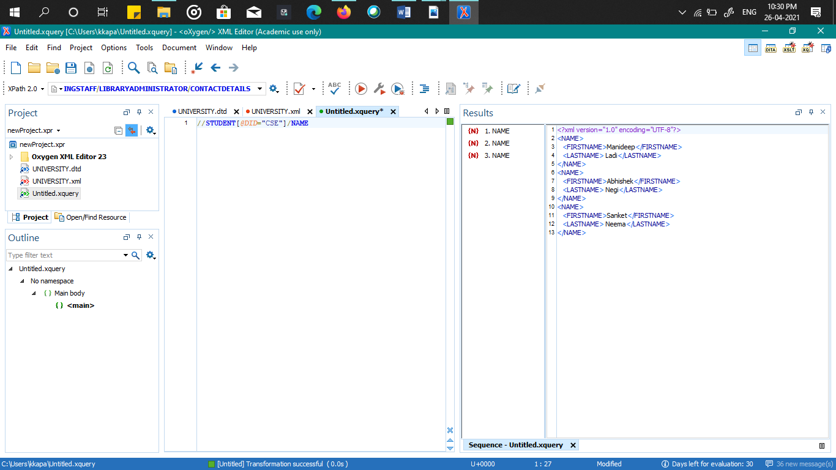

1. select the all the FOLLOWING siblings of the student id s003 ‘

//STUDENT[@SID=”S003”]/following-sibling::*

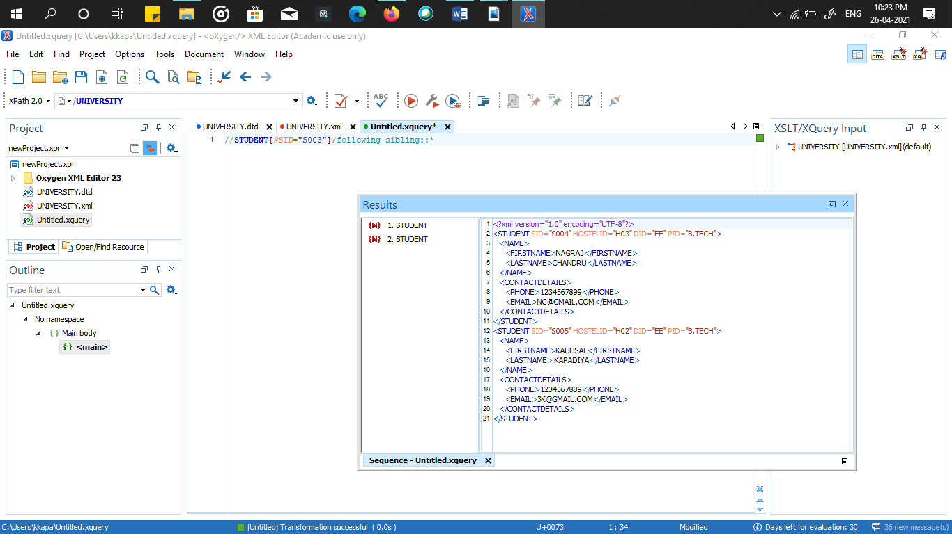

1. print the name of the hospital staff with HID Doctor001 ‘

//HOSPITALSTAFF[@HWID=”Doctor001”]/NAME

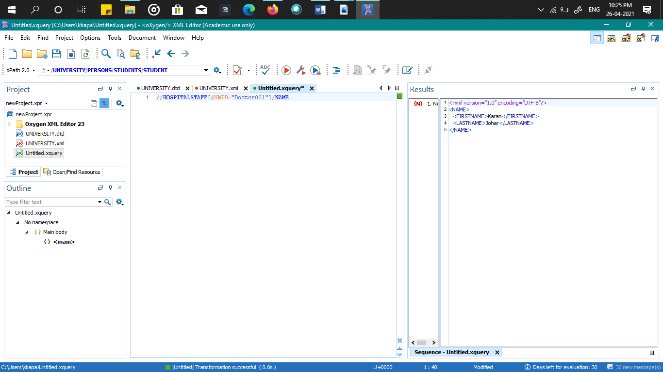

1. print the names of all students ‘

//STUDENT/NAME

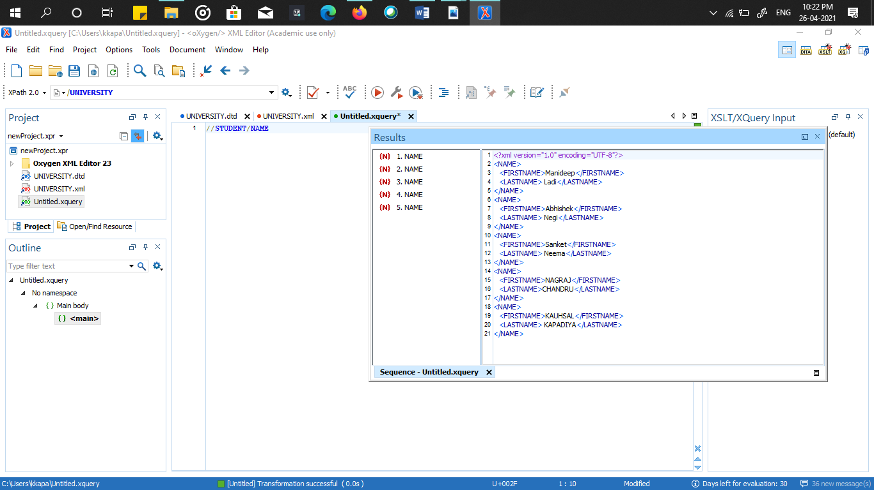

1. print the DETAILS of the book whICH contains one of its author as Michael Sipser ‘

//BOOK/AUTHOR[contains(.,’Michael Sipser’)]/..

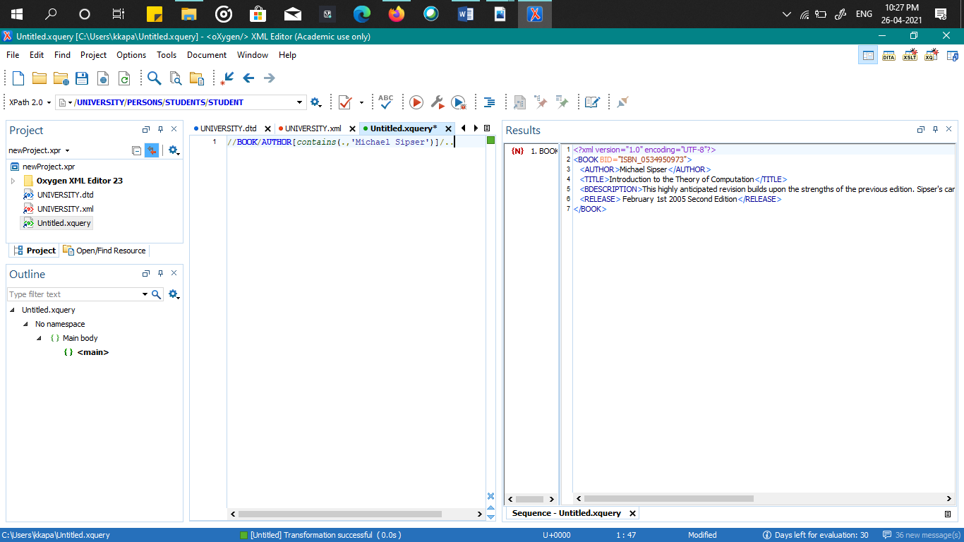

1. print the names of all non teaching staff ‘

//NONTEACHINGSTAFF/../NAME

